**1. What do you mean by AutoComplete feature in Excel and what are the**

**benefits of using this feature?  
  
Autofill is a browser feature that allows people to save information (on the browser or the OS) and use it on web forms.**

**The autofill framework improves the user experience by providing the following benefits:**

* **Less time spent in filling fields. Autofill saves users from re-typing information.**
* **Minimize user input errors. Typing is prone to errors, especially on mobile devices. Minimizing the need to type information also minimizes typos.**

**2. Explain working with workbooks and working with cells?**

**In**[**Microsoft**](https://www.computerhope.com/comp/msoft.htm)[**Excel**](https://www.computerhope.com/jargon/e/excel.htm)**, a workbook is a collection of one or more**[**spreadsheets**](https://www.computerhope.com/jargon/s/spreadsheet.htm)**, also called worksheets, in a single file.**

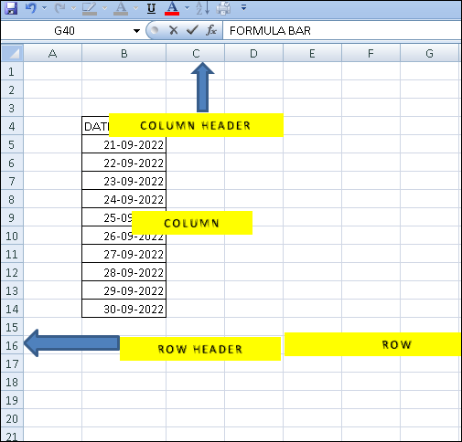

**3. What is fill handle in Excel and why do we use it?**

**Fill Handle is a feature in Excel that enables you to auto-complete a list in a row/column by simply dragging it using your mouse**

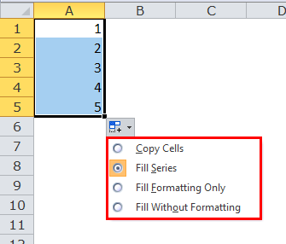

**4. Give some examples of using the fill handle?**

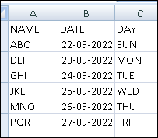

**5. Describe flash fill and what the different ways to access the flash fill are.**

**Flash Fill automatically fills your data when it senses a pattern. For example, you can use Flash Fill to separate first and last names from a single column, or combine first and last names from two different columns**

**THE DIFFERENT WAYS TO ACCESS THE FLASH FILL ARE**

**You can go to Data > Flash Fill to run it manually, or press Ctrl+E. To turn Flash Fill on, go to Tools > Options > Advanced > Editing Options > check the Automatically Flash Fill box.**

**6. Extract first name and last name from the mail id and then from the**

**address column, extract the city, state, and pin code using the flash fill.**

**Given below is an example of the columns you have to create. Paste the**

**screenshot of what you have created using the flash fill command.**

**Example: Mail Id, Address, First name, Last name, State, City, Pincode**

